KUTU CYBERCHEF ASSIGNMENT

The following screenshots below are the results I got when I input the encripted message on cyberchef with the correct decoding method…

- BASE 64 DECODE

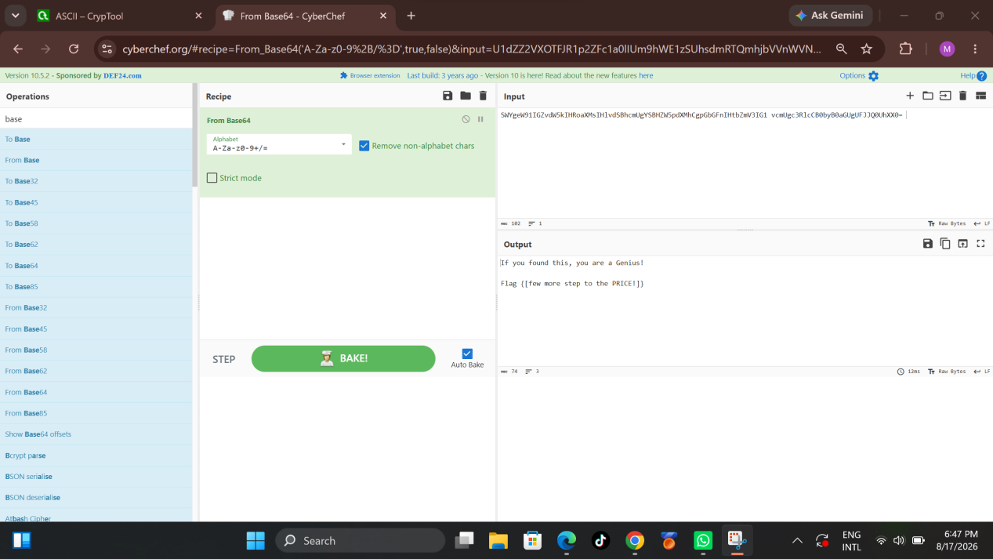

- HEX DECODE

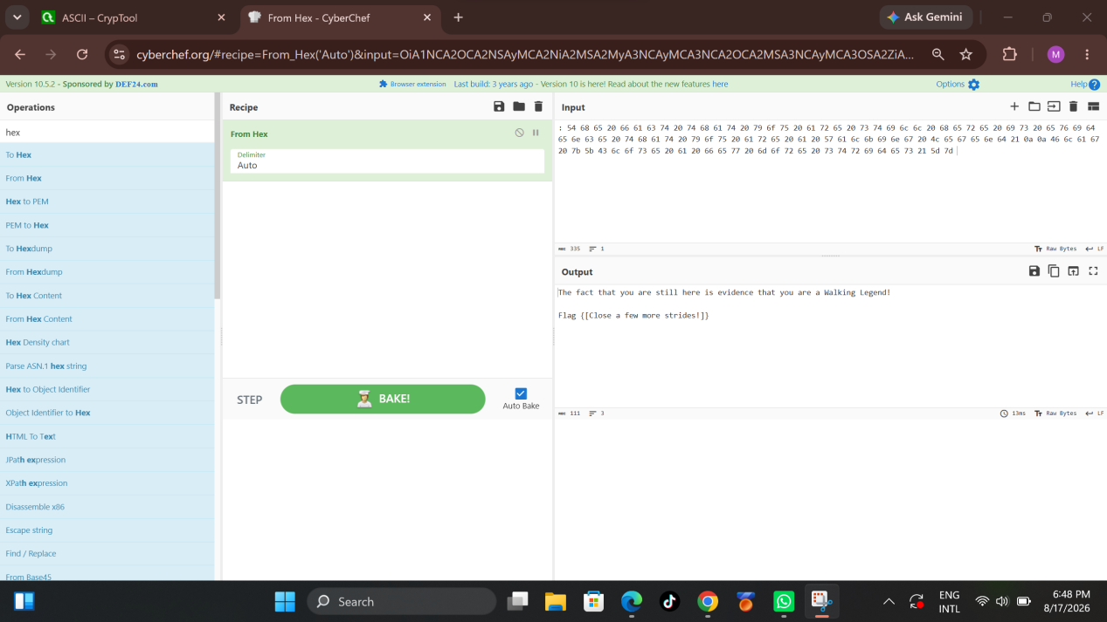

- BINARY DECODE

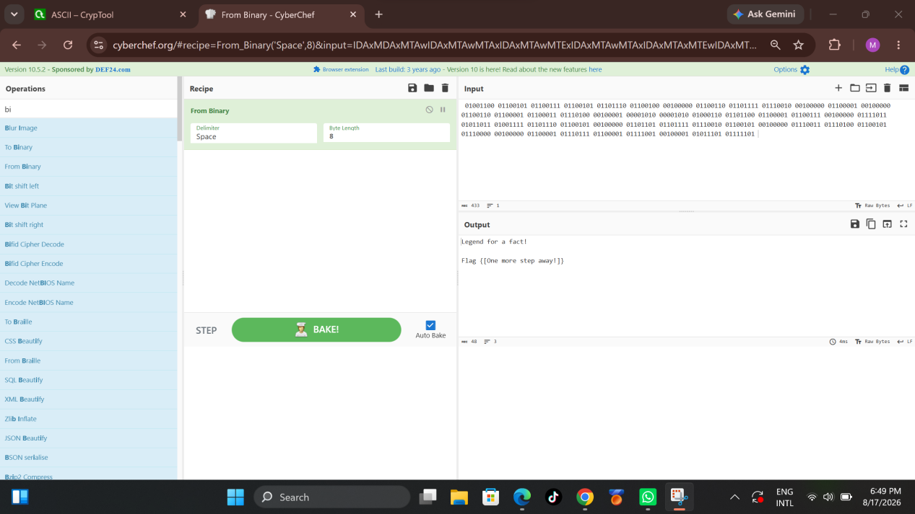

- RO13 DECODE

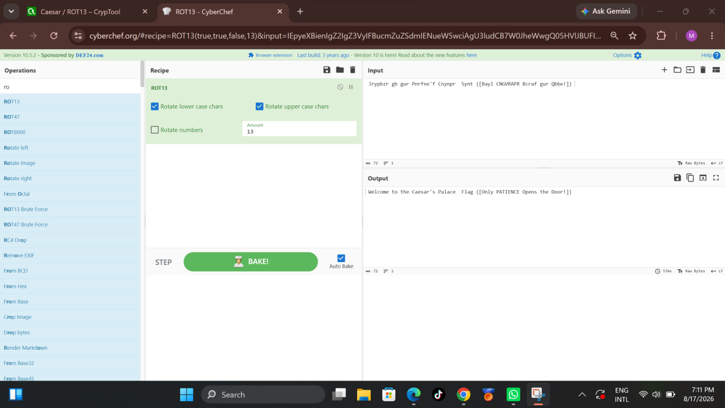

- URL DECODE

